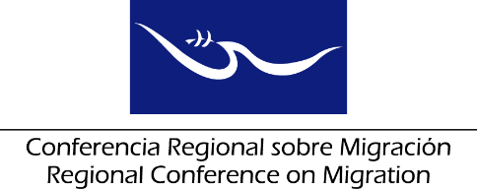 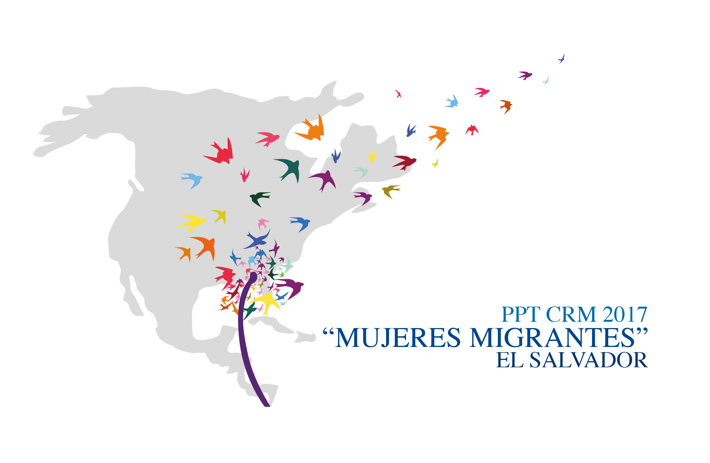

**Meeting of the Liaison Officers Network to Combat Migrant Smuggling and Trafficking in Persons**

**Regional Consultation Group on Migration (RCGM)**

**San Salvador, El Salvador**

# 21 June, 2017

**PRELIMINARY AGENDA**

08:30 – 08:45 Approval of the agenda

***[Leads: PPT]***

08:45 – 09:45 Country reports on the advances and challenges for the prevention and combat of the crimes of Trafficking in Persons and Migrant Smuggling.

***[Lead: All delegations (Five minutes per delegation)]***

Note: you are kindly requested to restrain your presentation only to RECENT efforts/practices and to keep the length of your presentation to a maximum of five minutes.

09:45 – 10:15 Revision of the comparative matrices on legislation in Migrant Smuggling and Trafficking in Persons, based on the update carried out by Member Countries regarding the degree of compliance of the Protocol to Prevent, Suppress and Punish Trafficking in Persons, Especially Women and Children and the Protocol against the Smuggling of Migrants by Land, Sea and Air.

• Degree of compliance of the indicators by the Member Countries

• Collection of indicators for consolidation by the TS

• Analysis and processing of information fromIOM indicators

***[Lead: All delegations, TS and IOM]***

10:15 –10:30 Break

10:30 – 10:45 Dialogue on the possibility of producing statistical data on Trafficking in Persons and Migrant Smuggling, according to the information gathered by Member Countries, which would be submitted to the TS for systematization.

***[Lead: All delegations]***

10:45 – 11:15 Presentation/dialogue with the RNCOM and the RCM on how to ensure the effective participation of the civil society in national and regional fora, especially regarding combating Migrant Smuggling and Trafficking in Persons.

***[Lead: All delegations]***

11:15 – 11:30 Dialogue on strengthening the consular capacities of each Member Country’s diplomatic missions on Trafficking in Persons and Migrant Smuggling.

***[Lead: All delegations]***

11:30 – 11:45 Presentation by the Regional Coalition against Trafficking in Persons and Migrant Smuggling.

***[Lead: Presidency and Technical Secretariat of the Regional Coalition]***

11:45 – 12:30 Preparation of the Network’s report for the RCGM

***[Lead: PPT with support from the TS]***

12:30 Closure