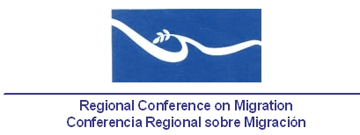

REPORT

Participation of the Coordinator of the Technical Secretariat at the International Conference on Migration, Childhood and Family

Tegucigalpa, Honduras

16 - 17 July, 2014

Participants

Costa Rica, El Salvador, the United States, Honduras, Mexico and Panama, as well as several United Nations Agencies, the Organization of American States, the Central American Integration System, international cooperation organizations and representatives from the civil society.

Report

During the two days of the meeting, the participants discussed about the establishment of strategies that may represent a framework for action and commitment to respond to the humanitarian emergency caused by the high migration flow of unaccompanied children to the United States, mainly originating in Guatemala, Honduras and El Salvador.

Thus, a final document outlining the main considerations and conclusions of participants was issued, including four main points proposed by the Government of Honduras to act jointly towards a regional initiative that will address the migration of unaccompanied children to the United States, within a framework of shared responsibility for peace, security, welfare and justice. The final document is attached.

