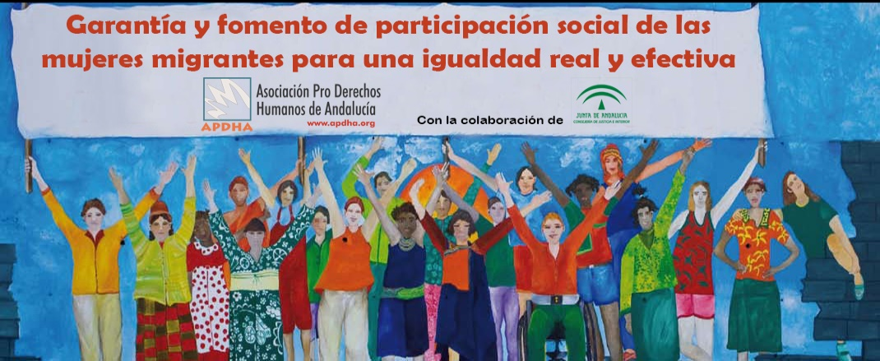

**First Regional Congress: Women in Migration Context**

**El Salvador, San Salvador**

**18 - 20 December 2018**

*-Conceptual Note-*

**Introduction**

The Regional Conference on Migration (RCM), as a regional consultation process committed to the human rights of migrant women, has promoted several initiatives throughout its 23 years of existence. "Migrant women" is a current topic with a significant impact on the migration dynamics of the region and that requires strengthening from regional and internal level of the Member Countries of this conference.

Member Countries of this conference have identified that the role of women in migration dynamics is increasingly relevant and has taken different facets when migrating because they not only undertake the journey by themselves, but also accompanied by their children; or once established at the country of destination, they then make great efforts to achieve family reunification.

In 2017, under the leadership of the Government of El Salvador, as the Presidency Pro-Témpore of the RCM, lines of work related to migrant women were built, with the objective of generating spaces of learning and reflection aimed at Member Countries to increase their knowledge about the intrinsic bond between women, migration and development. Thus, in compliance with the commitment acquired by Member Countries at the XXI Regional Conference on Migration in Honduras, the Forum – "Women, Migration and Development: a strategic challenge for the region" was developed on 27-29 November 2017.

As part of the conclusions of this Forum, it was pointed out the need to continue with the analysis of migration processes from a gender perspective in all its phases: prior to the departure from the country of origin unto the experiences, expectations and consequences in the countries of transit, destination and return. At this point, emphasis was placed on the opportunity to transversally incorporate this gender perspective into public policies, national and regional programs that, directly or indirectly, address the conditions that affect the entire migration process.

Similarly, and under the recommendation lines developed by this Forum, it is suggested that these public policies and programs be driven at the national level, in synergy with the different regional initiatives of dialogue. In this way, it would contribute with a greater impact on the recipients.

Thus, RCM Member Countries carry out a continuous work on the subject and provide technical support for the development of the document: " Guidelines on Assistance and Protection of Women in the Context of Migration", which is part of the project oriented to "Strengthening Public Policies to Protect and Empower Migrant Women in Mesoamerica", implemented by the International Organization for Migration (IOM), and funded by the IOM’s Development Fund.

This document responds to the commitment of the eleven Member Countries to promote, protect and guarantee the rights of migrant women in the region. Both countries of origin, transit and destination bond their efforts in favor of this population through this document, which will serve as reference for the elaboration, design and implementation of actions at national level in each one of the countries committed to this topic.

In addition to the support received from the International Organization for Migration and the United Nations Development Programme (UNDP) as observer organizations of the RCM, Member Countries of this Conference have created a precedent to ensure that women's migration is developed under optimal conditions, with respect for their rights, and promote them as agents of change for themselves, their families and their communities.

**Objetive**

To offer a space for the discussion, dialogue and the creation of conclusions based on the experience of the participating delegations on women in migration context.

**Methodology and Content**

Work tables, panels and colloquiums will be held under the following themes: Women and work, Gender-focused Data, Women and the Global Compact, Migrant Children and Adolescents, Women and SDG, Violence against women (for further information, see attached agenda).

**Venue and Date**

Ministry of Foreign Affairs of San Salvador, El Salvador, 18-20 December, awaiting arrival of participants on the 17th and departure on the 20th in the afternoon.

**Participants**

Three officials per country are expected, ideally on from institutions working on:

1. Protection, care and assistance of women,
2. Immigration Departments
3. Ministry of Foreign Affairs.

The invitation is also extended to the Regional Network of Civil Organizations on Migration (RRCOM) and the Observer Organizations of the CRM.