 | 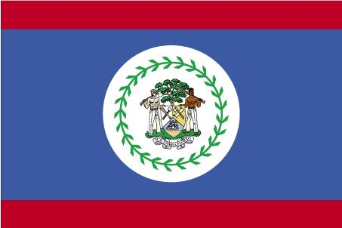  Belize |   Canada | 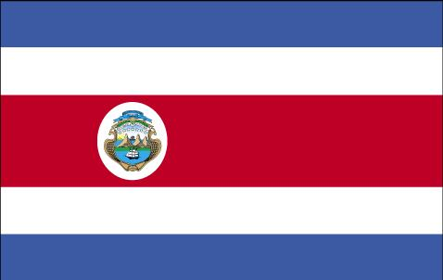  Costa Rica | 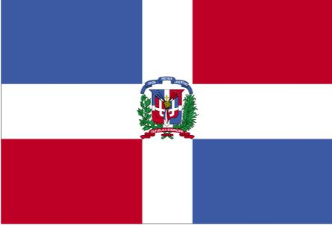  Dominican Republic | 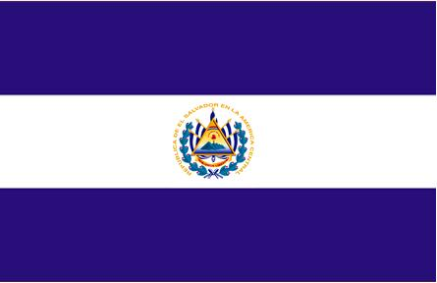  El Salvador | 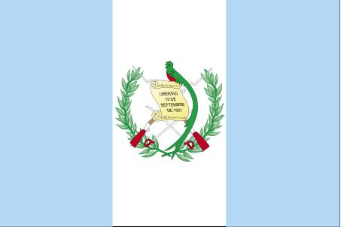  Guatemala |   Honduras |   Mexico |   Nicaragua | 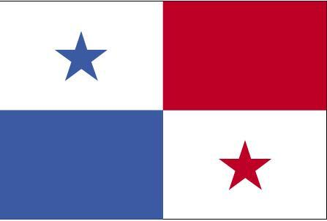  Panama |   United States
1. Basic country information

a. Total Area (km2) |  | 10,987,685
b. Total Population |  | 30,651,000
c. Percentage of pop. that is  - Urban  - Rural |  | 73 %  27 %
d. Main/Official Language(s) Spoken |  | English  French
2. Migrant Population General Information

a. Approximate Total Population born abroad (as a Percentage of total country population) |  | 18 %
b. Main immigrant groups, as a percentage of total migrant population:  - by national or ethno-linguistic origin  - by religion |  | - West Euro-pean (24 %)  - Chinese and South-east Asian (19 %)  - Indian and South Asian (17 %)  - Christian (45 %)  - Muslim  (14 %)  - Other reli-gions (32 %)
c. Main areas of immigrant employment |  | Services, health, commerce, high-tech
d. Approximate yearly Intake of Immigrants (not including refugees) |  | 285,000
e. Approximate number of refugees accepted (incl. resettled, sponsored and in-country arrivals) |  | 28,000
f. Approximate Yearly Total Granted Citizenship |  | 75,000
g. Yearly Population Growth |  | 1.2 %
h. Birth rate |  | 0.8

3. Residence Status in Destination

a. Types of residence visas (simplified breakdown by purpose and duration or conditions) |  | - Temporary residence (with or without work permit): 3 - 12 months  - Permanent residence: maximum allowed absence from country is 6 months per year
b. Length of residence required to achieve permanent resident status |  | N/A
c. Length of residence required to obtain citizenship |  | 3 years
4. Access to Public Services

a. Education |  | Yes
b. Health |  | Yes
c. Social services and assistance |  | Yes
d. Housing |  | Yes
e. Legal assistance |  | Yes
5. Access to labor market

a. Equality of opportunity legislation |  | Yes
b. Foreign credential recognition |  | Yes
c. Restrictions to exercising certain professions |  | Yes
6. Public attitudes towards migration

a. Existence of public opinion surveys and use in policy development |  | Yes
b. Official tracking or monitoring of coverage of migration and integration issues in the media |  | Yes
c. Public information or awareness initiatives for immigrant acceptance or integration |  | Yes

7. Legislation relating to integration

a. Constitutional norms |  | Canadian Charter of Rights and Freedom
b. Other key legislation |  | -Canadian Bill of Rights (1960)  -Immigration and Refugee Protection Act (2002)  -Official Languages Act (1985)  -Canadian Human Rights Act  (1985)  -Citizenship Act (1985)  -Employment Equity Act (1995)  - Multicultu-ralism Act (1988)
8. Government integration programs in place

Name of program(s)/initiatives and their specific  See footnotes for detail on  - a)objective  - b) target population  - c) who delivers program |  | 1) Canadian Orientation Abroad  2) Going to Canada Immigration Portal  3) Immigrant Settlement & Adaptation Program (ISAP)  4). Language Instruction for Newcomers (LINC)  5). HOST  6) Enhanced Language Training (ELT)  7) Refugee Assistance Program (RAP)
Other initiatives |  | -Federal Government – yes  -Provincial & Territorial governments – yes  -Not-for profit sector – yes  -Private sector -yes

Footnotes (by country)

Canada:
3.a.- Work permits are separate from temporary residence visas. Temporary residence visas may be issued without a work permit, but work permits cannot be issued without a temporary residence visa.
3.b.- Temporary residence status does not lead to permanent residence status. Although previous residence in Canada may be taken into account when processing a request for permanent residence, a permanent residence visa requires an application process separate from the temporary residence visa.
[.....]
4.d.- Persons accepted as refugees receive a one-year subsidy for housing.
[...]
5.b.- Some occupations require validation of foreign credentials (f.ex., health professionals, engineers), and in most cases this is done by private (non-government) professional associations at the provincial level. Difficulties in prompt and adequate recognition of foreign credentials has prompted a policy review, with a new system being developed for implementation nationally.
[....]

Integration Programs: Detailed Information on:
a) program objective
b) target population
c) who delivers program

CANADA

Overview: Jurisdiction for immigrant integration is shared between the federal government and the provinces and territories. The authority for federal settlement programs is within the Immigrant and Refugee Protection Act. The federal government believes that partnerships with stakeholders will result in optimal services for clients. Partners include other federal government departments, provinces and territories, the not-for-profit sector and the private sector. Other government and stakeholders initiatives can contribute to the integration process. Programs are designed and delivered in a decentralized fashion so as to reflect the needs of a particular community. Delivery is through 3rd party arrangements with non-governmental organistions.
1) Canadian Orientation Abroad
a) Orientation sessions offered in some countries to provide future newcomers with some familiarity with life in Canada prior to arrival eg. employment; rights & responsibilities; climate; finding a place to live; living in a multicultural society; the cost of living; family life; education; communications; and adaptation to Canada.
b) Permanent Residents; Temporary Residents; Live-in Caregiver Program; Protected Persons
c) International NGO (currently the International Organization for Migration

2) Going to Canada Immigration Portal
a) Online information, services and tools to enable immigrants to make informed decisions and facilitate their integration into Canada’s communities and labour market. (In development.)
b) Prospective immigrants and recent newcomers with an emphasis on foreign trained professionals
c) Federal Government; Provinces / Territories

3) Immigrant Settlement & Adaptation Program (ISAP)
a) A range of settlement services e.g. needs assessment, information/orientation, referrals to community services, solution-focused counseling, employment-related services, interpretation/translation services, “Welcome to Canada” services at Ports of Entry, Newcomers Introduction to Canada (publication), and bridging between immigrant-specific services and those available to the broader population.
b) Permanent Residents; Protected Persons; Persons in Canada whose applications for Permanent Resident have been approved in principle pending an admissibility assessment;
Temporary Resident; Live-in Caregiver
c) Provinces, Territories or Municipalities; Non-governmental organizations; Non-profit corporations; Community groups; Businesses; Educational institutions (including school boards, districts and divisions)

4). Language Instruction for Newcomers (LINC)
a) Language assessment and training in either English or French to facilitate social, cultural, economic, and political integration.
b) Adult immigrants: Permanent Residents; Protected Persons; Persons in Canada whose applications for Permanent Residence have been approved in principle pending an admissibility assessment.
c) Service Provider Organisations; Provinces/Territories; Educational Institutions

5). HOST
a) Volunteer-based matching program - Canadians who host/mentor permanent residents. Funding to recruit, train, support and match.
b)-Permanent Residents; Protected Persons; Persons in Canada whose applications for Permanent Residence have been approved in principle pending an admissibility assessment.
c) Provinces, territories or municipalities; Non-governmental organizations; Non-profit corporations; Community groups; Businesses; Educational Institutions (including school boards, districts and divisions)

6) Enhanced Language Training (ELT)
a) Labour market-level and occupation-specific language training, accompanied by bridge-to-work activities such as internships, business mentoring, and orientation to the Canadian work environment.
b) Same as above destined for the labour market
c) Provinces / territories; Employers; Municipalities; Service provider organizations

7) Refugee Assisatance Program (RAP)
a) Income support for up to 12 months following arrival (24-36 months in exceptional cases) and range of initial reception and orientation services including temporary housing, location of permanent housing and financial and non-financial orientation for life in Canada.
b) Government-assisted refugees
c) Service provider organizations; Provinces / territories; Sponsorship Agreement Holders

Entries in sections 4 and 5 are Yes or No answers (Yes/No), with possibility of a footnoted entry for each if additional information or clarification is needed. For entries in section 4, if access varies depending on type of visa or residence status, please indicate each type of visa or residence status before indicating a Yes or a No for it.

